Requirements/Design Specification

**July2015 GH325**

**Rate Restrictions - Determine how to program around errors**

**(CR 14087)**

Revision History

|  |  |  |  |
| --- | --- | --- | --- |
| **Date** | **Revision** | **Description** | **Author** |
| 5/18/2015 | 1.0 | Initial Version with Requirements | Gaurav Dawar |
|  |  |  |  |
|  |  |  |  |
|  |  |  |  |
|  |  |  |  |

The information furnished herein by Republic Services Inc. is proprietary and confidential to Republic Services Inc. personnel and is not to be duplicated, published, or disclosed to any third party in whole or in part without permission from Republic Services, Inc.

© Copyright 2012, Republic Services Inc. - All rights reserved.

Table of contents

1 Business Requirements 6

1.1 Purpose of the Design Specification 6

1.1.1 Bug list for current release 6

2 Competitor Overview and Assumptions 6

3 Design 6

4 Impacted Systems (InfoPro, TIBCO and BI) 8

5 Report Changes 8

6 Appendix 8

# Business Requirements

## Purpose of the Design Specification

This document highlights items to be fixed and implemented for the titled release.

### Bug list for current release

| GitHub Item  Number | **Description** |
| --- | --- |
| 325 | Rate Restrictions - Determine how to program around errors (CR 14087) |

# Overview and Assumptions

Since the text boxes for “After year 1” and so on in “Customer Rate Restriction” are free flow text boxes without any validation on them i.e. a rep can put in anything in them which is why data flowing to infopro is not consistent.

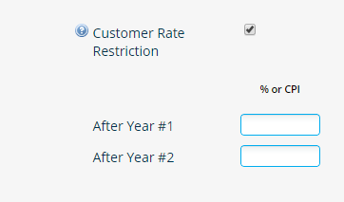

# Design

## #325 Rate Restrictions - Determine how to program around errors (CR 14087)

To resolve the Issue mentioned above, a validation rule is to be created to validate and throw an error if the value put in the text boxes is not a “Float” upto 2 decimal places or the word “CPI”. Also, the “Rate Firm until” string ends with a date and that date needs to be updated based on the values in the “After Year” text boxes.

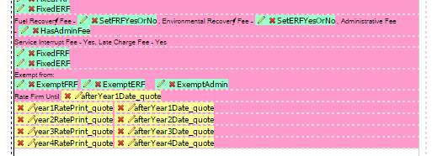

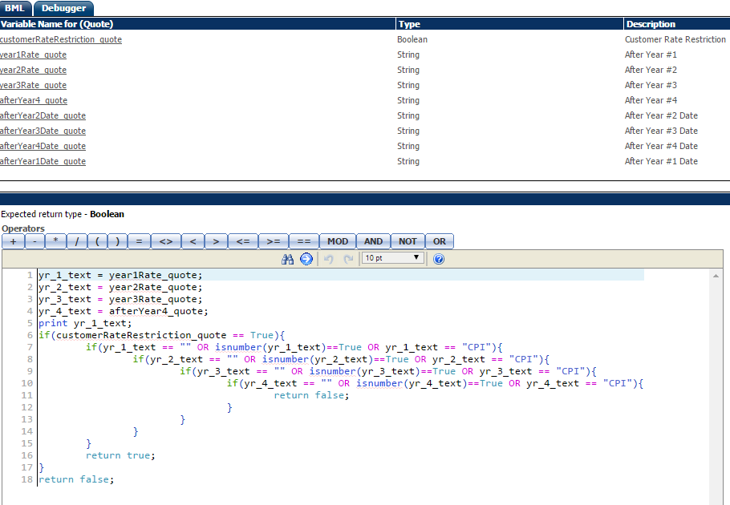

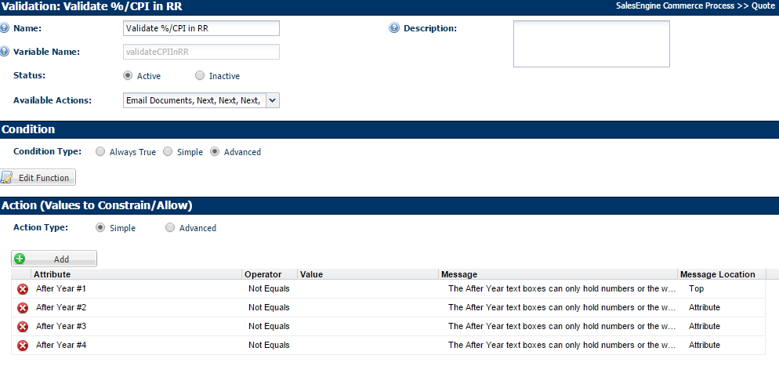

# Impacted Systems (InfoPro, TIBCO and BI)

No new variables are created, hence this fix will not affect InfoPro AAE process.

Now, the text boxes taking the %ages for each year can take first 6 characters and truncate rest.

# Report Changes

NA

# Appendix